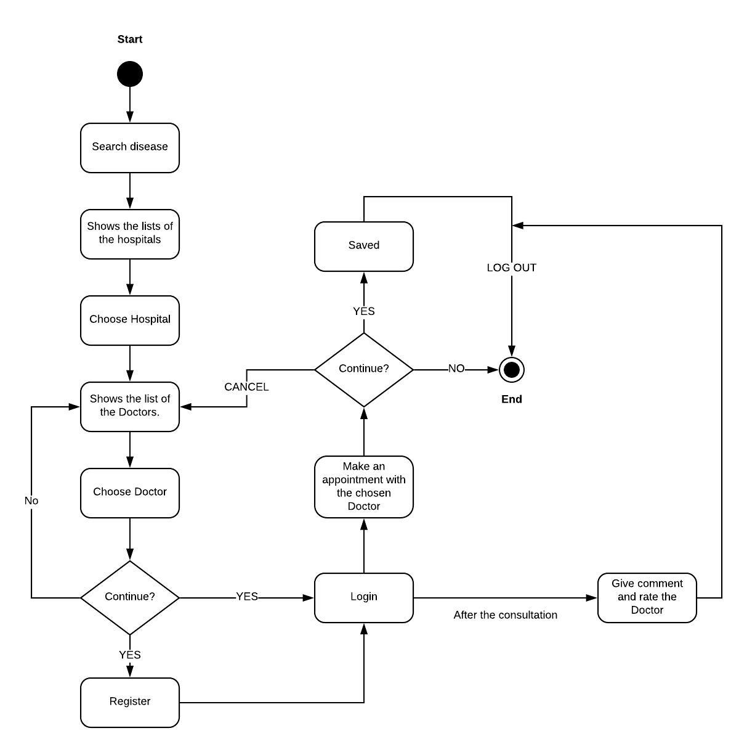**Activity Diagram of Health Care Consultant**